Bountiful Foods Site Plan

Site Purpose:

Bring a quality experience to all Bountiful Foods’ customers through a well elaborated and interactive website.

The web page will meet all web quality standards including image optimization and view response in major viewports.

Target Audience:

People residing in Carlsbad or the coastal area of California interested in purchasing organic food.

Personas:

Persona 1:

Daniel lives in California. He’s 35 years old and has 4 kids. He works for a local bank. He loves healthy food.

Persona 2:

Sarah is 20 years old. She likes to exercise every day. She’s a college student.

Scenarios:

1: A local market is interested in acquiring our products to display in their healthy food week.

2: A tourist that travels regularly to Carlsbad is interested in visiting the business website to have fresh items delivered to their hotel.

Site Map:

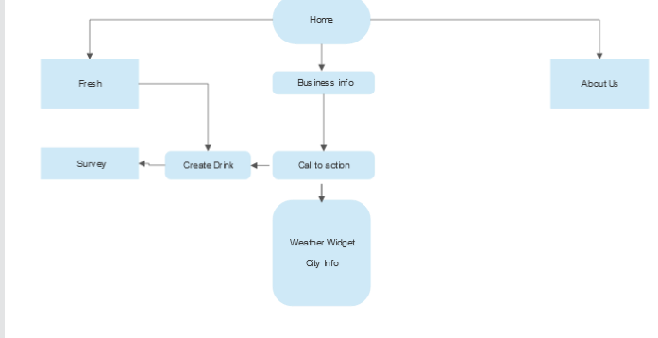

Color Scheme:



https://coolors.co/000000-0e402d-295135-5a6650-9fcc2e

Title Typography:





Paragraph Typography:





<link rel="preconnect" href="https://fonts.googleapis.com">

<link rel="preconnect" href="https://fonts.gstatic.com" crossorigin>

<link href="https://fonts.googleapis.com/css2?family=Open+Sans:wght@300&family=Roboto&display=swap" rel="stylesheet">

Wireframe Sketches:

Small:

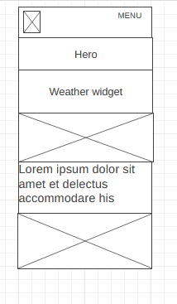

Medium:

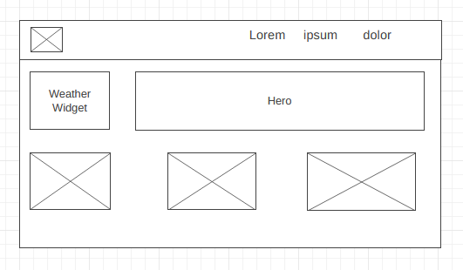

Large:

